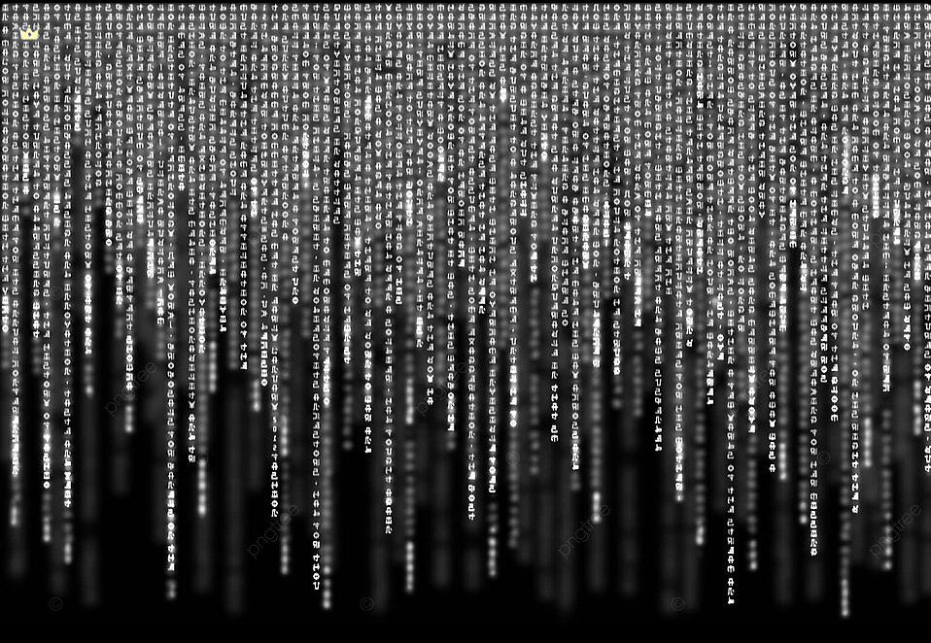

**PROJECT SYNOPSIS**

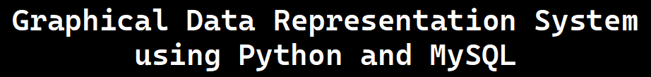

**Credits:**

**Raj Rishi Rana**

**Satyam Kumar**

**CERTIFICATE**



**This is to certify that Mr. Raj Rishi Rana of std. XII Navy Children School, Mumbai has put in sincere and dedicated efforts towards the project. His work has been highly appreciative.**

**Sign of Head of Department Sign of Principal**

**School Stamp**

**ACKNOWLEDGEMENT**

*I would like to express my special thanks of gratitude to my teacher Mrs. Sapna Malik as well as our Principal Dr.(Mrs) Nandana Khare who gave me the golden opportunity to do this wonderful project in computer science on the topic “Graphical Data Representation System using Python and MySQL”, which also helped me in doing a lot of research and I came to know about so many new things I am really thankful to them.*

*Secondly I would also like to thank my parents and friends who helped me a lot in finalizing this project within the limit of time frame.*

**Table of Contents**

* **Cover Page**
* **Certificate**
* **Acknowledgement**
* **Index**
* **Software Specification**
* **Project Description**
* **Implementation**
* **Output**
* **Bibliography**
* **Future Scope**

**Software Specification**

· **Programming Language**:

* **Front-end** : **Python 3.13**

Python is a high-level, versatile programming language known for its simplicity and readability, making it a popular choice for beginners and experts alike. Developed in the late 1980s by Guido van Rossum, Python emphasizes clear, concise syntax, allowing developers to focus on problem-solving rather than complex code structures. Its extensive standard library supports tasks ranging from web development and data analysis to artificial intelligence and scientific computing. Python’s flexibility and adaptability stem from its compatibility with various libraries and frameworks, such as Django for web development, NumPy and Pandas for data manipulation, and TensorFlow for machine learning. With a large, supportive community and continuous development, Python has become a preferred language for a wide range of applications across industries, known for accelerating development and enhancing productivity.

* **Back-end** : **MySQL 8.0**

MySQL is a widely used open-source relational database management system (RDBMS) known for its speed, reliability, and flexibility. Developed in the mid-1990s by Swedish developers, MySQL quickly gained popularity due to its ease of use and powerful capabilities, especially in web applications and data management. MySQL is based on Structured Query Language (SQL), which allows users to create, manipulate, and manage databases effectively. It supports a wide range of platforms, including Windows, Linux, and macOS, and integrates seamlessly with popular programming languages like Python, PHP, and Java. MySQL is highly scalable, capable of handling large data volumes, and includes robust features for data security, transaction processing, and concurrency. Its popularity as the backbone of numerous web applications, including social media sites and e-commerce platforms, is supported by its active community and ongoing development under Oracle Corporation.

· **Modules Used**:

* tkinter: For creating the graphical user interface.
* matplotlib.pyplot: For plotting graphs.
* mysql.connector: For connecting and querying MySQL databases.
* numpy: For array handling.
* math: For mathematical operations.

· **Database**: MySQL

· **IDE Used**: PyCharm (JetBrains IDEs)

· **Operating System**: Linux

### **Project Descriptionbgnot(1)(1)**

This project, "**Graphical Data Representation System using Python and MySQL**" aims to simplify **data visualization** for mathematical equations and database tables. The program uses a Tkinter GUI, where users can input either a mathematical equation or the name of a MySQL database and table. The program processes the input and generates a graphical representation of the data.

* **Objective**: To provide an easy-to-use tool for visualizing data and mathematical functions.
* **User Input Options**:
  + **Mathematical Equation**: The user enters a formula, and the program calculates values using numpy and plots the result.
  + **Database Table**: The user provides the name of a MySQL database and table, and the program retrieves data and plots it.

This system leverages Python's data processing and graphical capabilities to create a user-friendly experience for data visualization.

### **bgnot(1)(1)Implementation**

1. **Importing modules**



1. **Initializing**

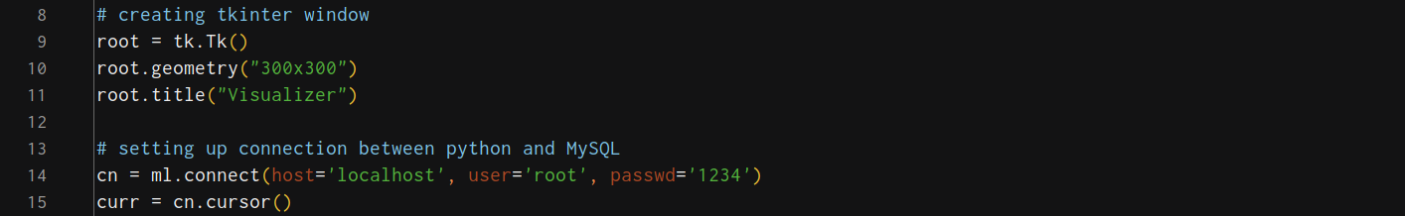

1. **Defining functions**

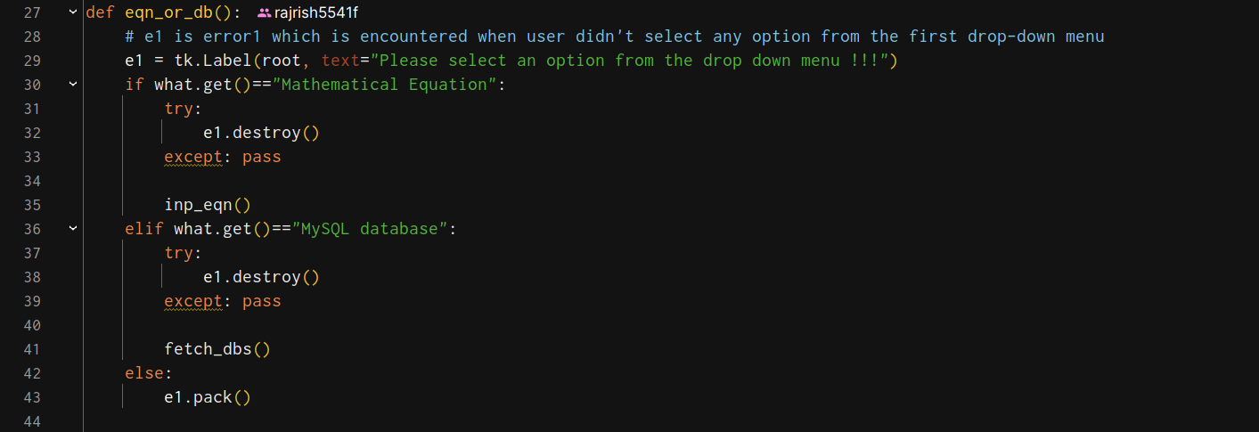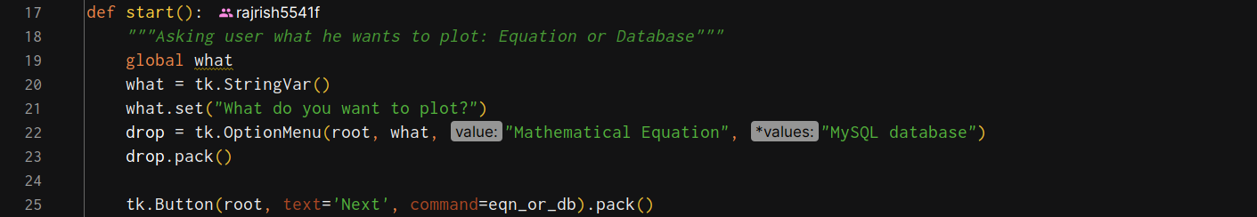

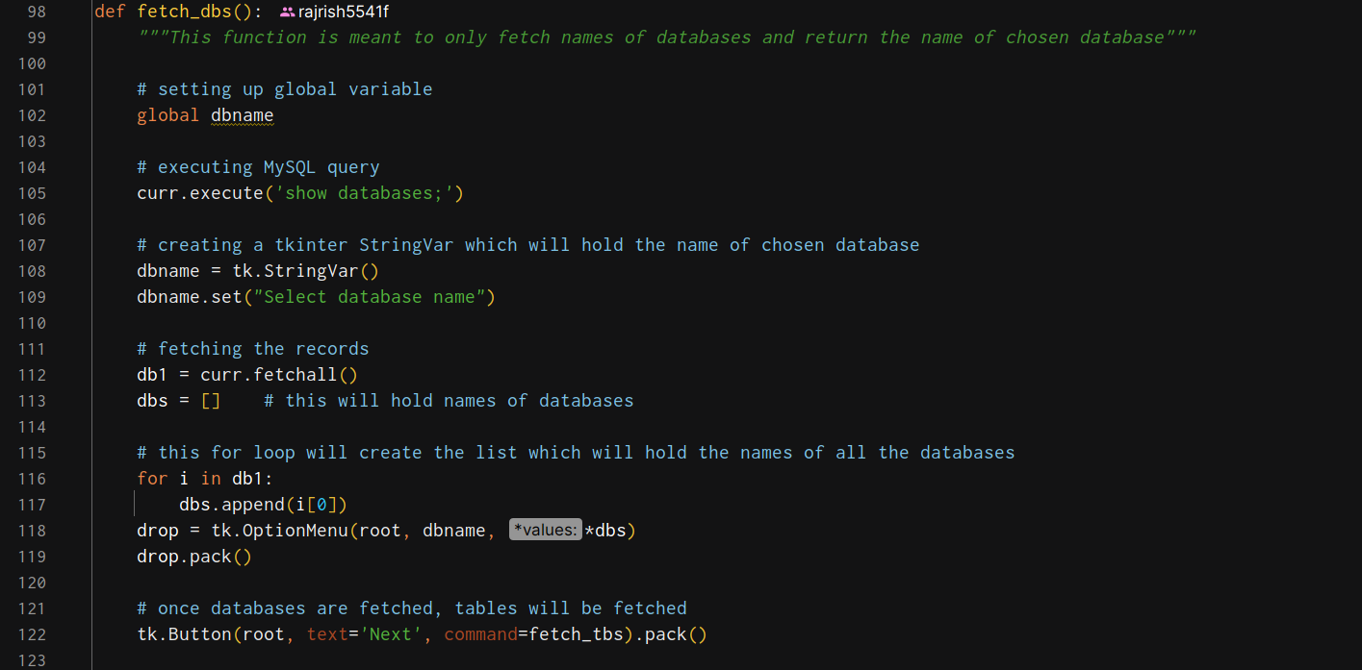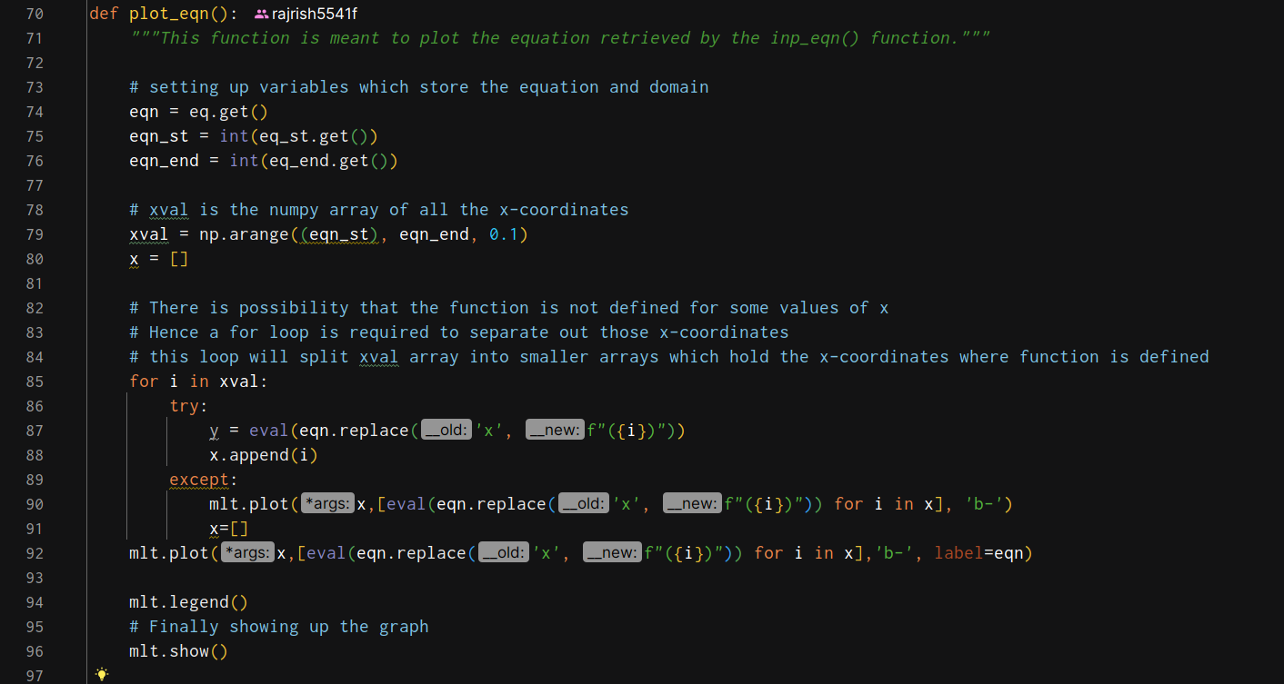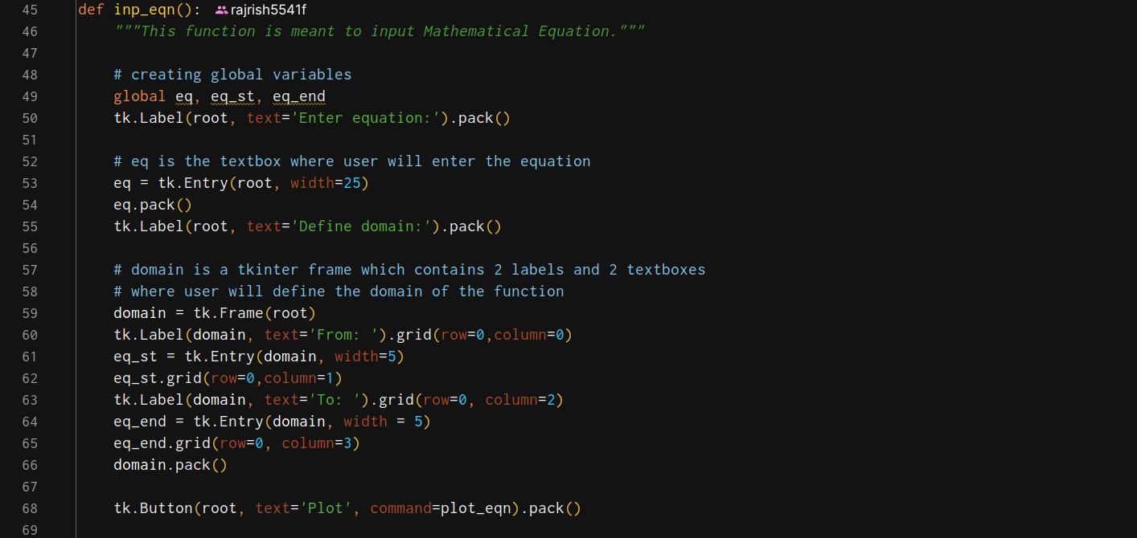

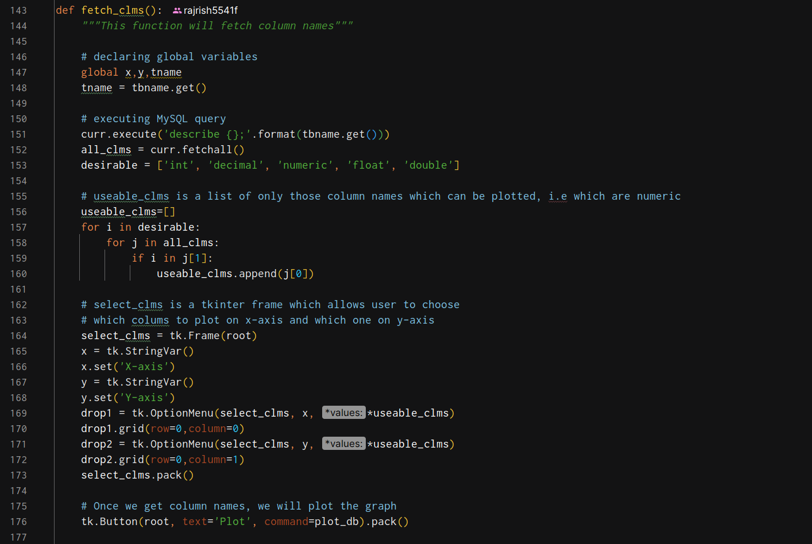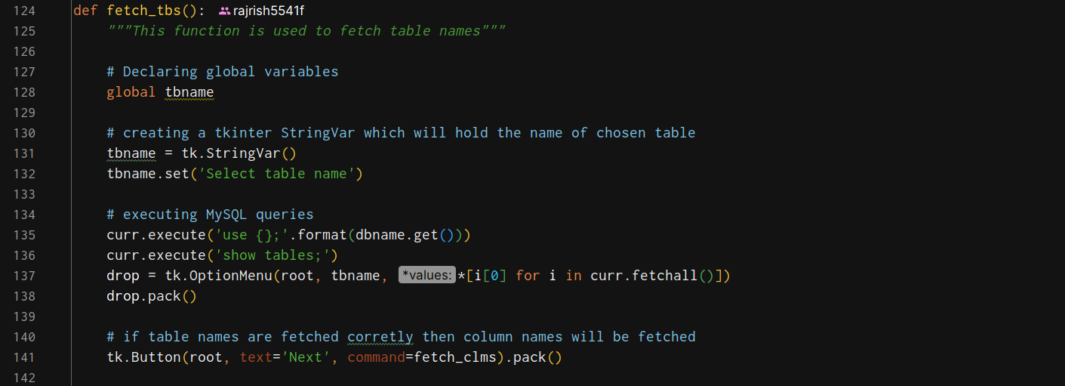

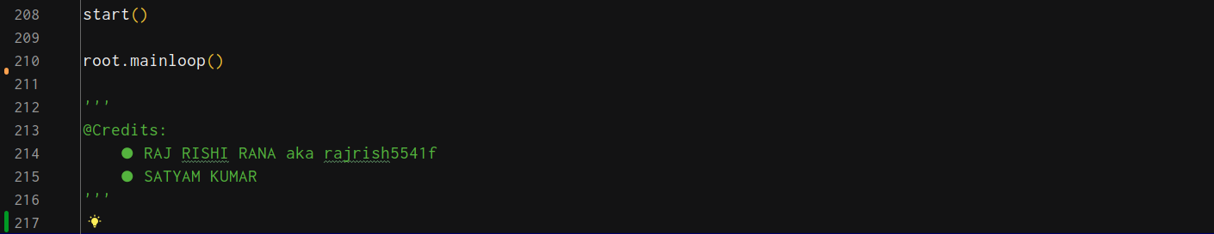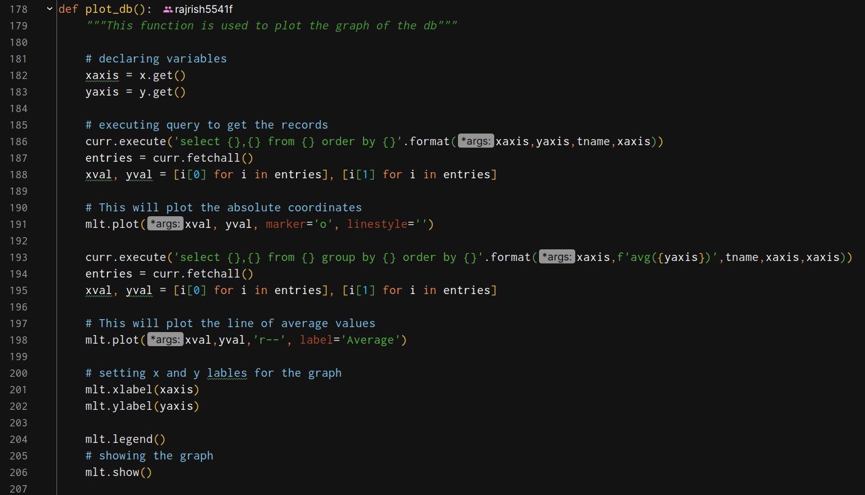

**Source code available at github.com -**

[CS-11-12/Projects/Project Synopsis at main · rajrish5541f/CS-11-12](https://github.com/rajrish5541f/CS-11-12/tree/main/Projects/Project Synopsis)

### **bgnot(1)(1)Output**

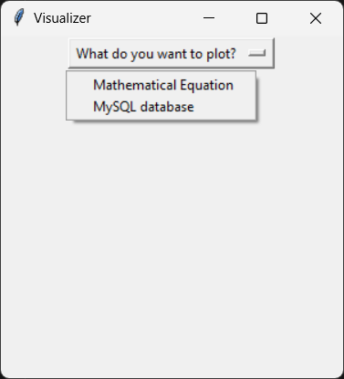

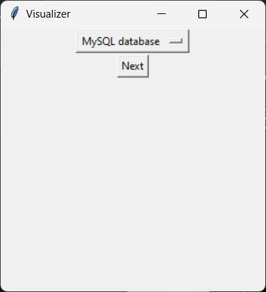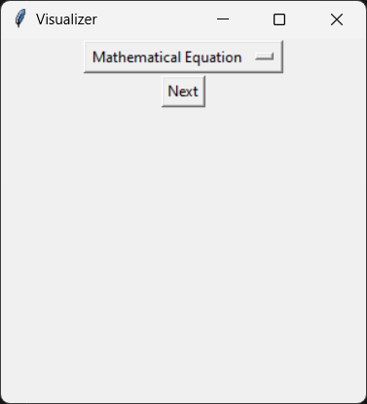

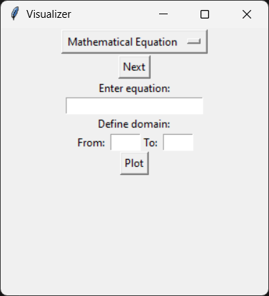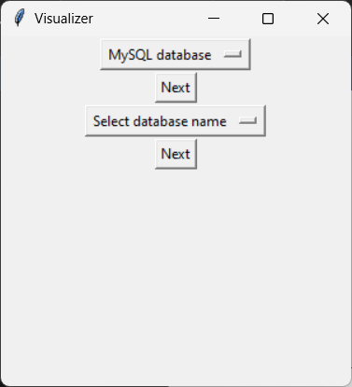

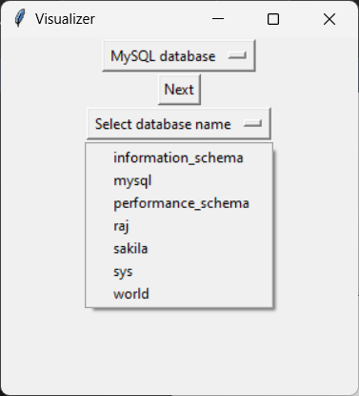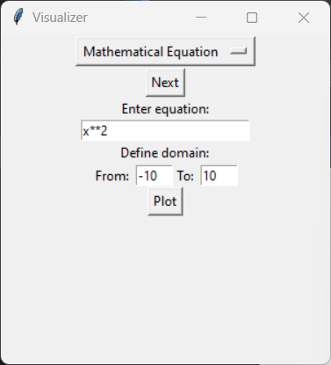

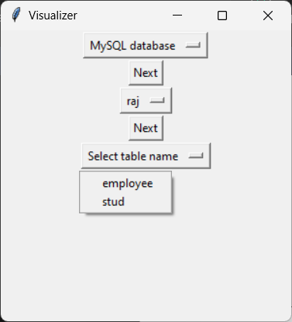

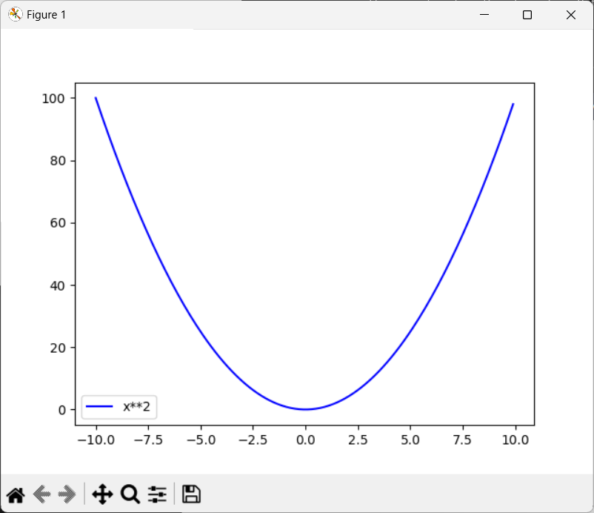

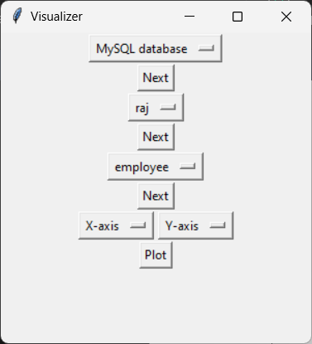

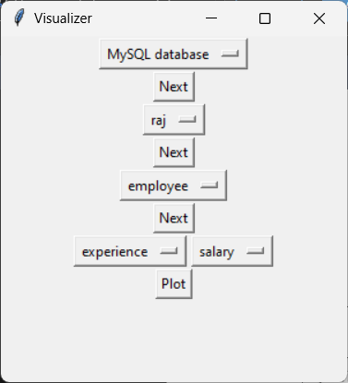

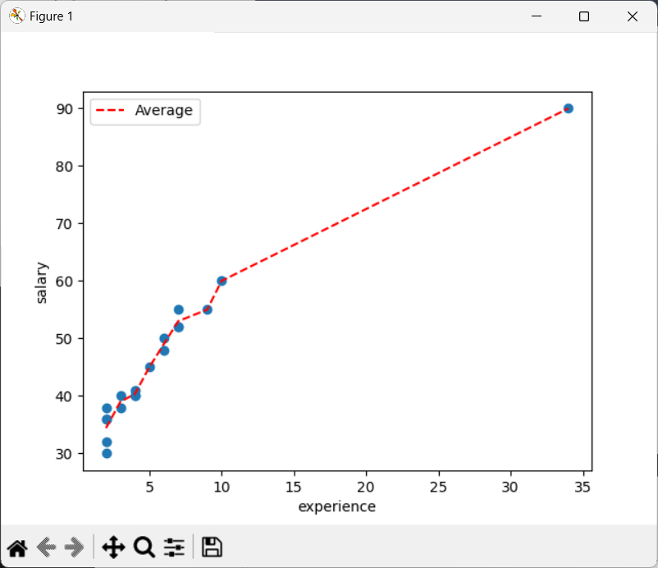

**Bibliography**

· **Python Documentation**: https://docs.python.org/

· **Matplotlib Documentation**: https://matplotlib.org/

· **MySQL Documentation**: https://dev.mysql.com/

· **Stack Overflow**: <https://stackoverflow.com/>

· **Youtube Handles**:

<https://youtube.com/@freecodecamp/>

https://youtube.com/@SurfsharkAcademy/

[https://youtube.com/](https://stackoverflow.com/)@Codemycom/

<https://youtube.com/@CodeWithHarry/>

<https://y>outube.com/@CodingWithLewis/

**Future Scope**

* **Enhanced Visualization Options**: Adding support for more types of plots like bar charts, pie charts, and histograms for varied data analysis.
* **Extended Database Support**: Expanding to support additional databases like PostgreSQL, SQLite, or cloud databases.
* **Complex Mathematical Expressions**: Allowing users to input more complex expressions with multiple variables.
* **Data Analysis Tools**: Incorporating basic data analysis functions (e.g., mean, median, mode) for database data to provide deeper insights.